# Sample Questions Task 1:

Write a PHP program where each section has details such as a name, score, and status, you need to ensure that the formatting includes appropriate indentation for each section.

$sections is an associative array where each key represents a section (e.g., "Section A") and each value is an array containing details for that section (e.g., name, score, and status).

**Expected Output:**

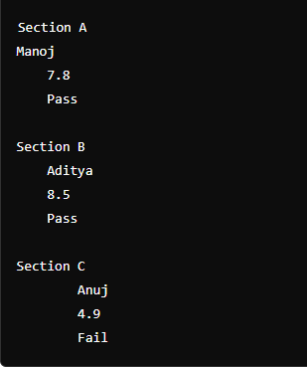

# Task 2:

Write a PHP Program where each section includes a course name and its associated details (name and copies), you can use an associative array to store the data and then iterate over it to print each section in the required format.

* $courses is an associative array where each key represents a course name (e.g., "C++", "PHP", "Laravel").
* Each key maps to another associative array containing "name" and "copies" for that course.

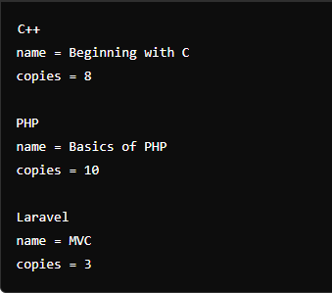

# Task 3:

Write a Program in PHP to print the Following Pattern:

**Expected Output:**

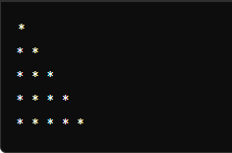

**Define Number of Rows**:

* $rows = 5; specifies the number of rows for the pattern.

# Task4:

Write a Program in PHP, where each row contains letters of the alphabet increasing from 'A' to a specific letter, you can use nested loops. The outer loop controls the number of rows, and the inner loop prints the letters in each row.

**Define Number of Rows**:

* $rows = 5; specifies the number of rows for the pattern.

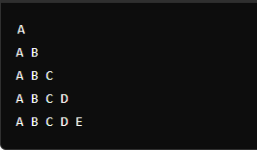

# Task5:

Write a Program in PHP where each row contains an increasing sequence of numbers from 1 to a specific number, you can use nested loops. The outer loop controls the number of rows, and the inner loop prints the numbers in each row.

**Define Number of Rows**:

* $rows = 5; specifies the number of rows for the pattern.

**Expected Output:**

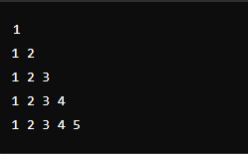

# Task6:

Write a program in PHP that is well-structured to achieve the desired output using an associative array. The foreach loop iterates over the associative array and prints each key-value pair in the specified format.

**Array Definition**:

* $superhero is an associative array where:
  + Keys are "name", "email", and "age".
  + Values are "Peter Parker", "[peterparker@mail.com](mailto:peterparker@mail.com)", and 18, respectively.

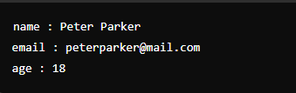

# Task7:

Given Array

$arr = [5, 2, 8, 3, 1];

1. Find the Largest Number among three Numbers in PHP?
2. Sort the unique ages in ascending order.

Write a Program in PHP to print the Following Expected Output:

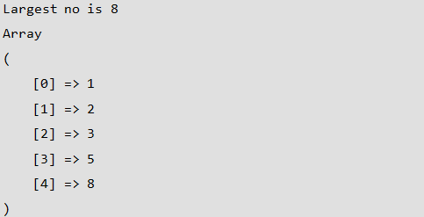

# Task 8:

Write a Program in PHP to print the Fibonacci series

**Function Definition (printFibonacci($n))**:

* + Takes an integer $n representing the number of terms to print in the Fibonacci series.

**Initialization**:

* + $a and $b are initialized to 0 and 1, the first two numbers in the Fibonacci series.
  + The first Fibonacci number (0) is printed before entering the loop.

# Expected Output:



**Task9:**

Write a Program in PHP to print the Factorial of 5

**Function Definition** (factorialIterative($n)):

* + Initialises $result to 1.
  + Uses a for loop to multiply $result by each number from 1 to $n

# Expected Output:



**Task 10:**

Write a Program in PHP that prints course information with headings for each chapter and summaries for chapters 1 through 5, you can use associative arrays to store the details of the course and then loop through the array to print the information.

**Array Definition**:

* + $courseInfo is an associative array with:
    - "courseName" key holding the name of the course.
    - "chapters" key holding another associative array where keys are chapter numbers, and values are chapter summaries.

foreach ($courseInfo["chapters"] as $chapterNumber => $summary)

iterates over each chapter in the "chapters" array.

